**Use table in smartformsZRT_SMART**

For the initial steps to create a smart form, please refer the previous demos.

1. Create a smart form .

2) Double click on Global Definitions and declare the following.

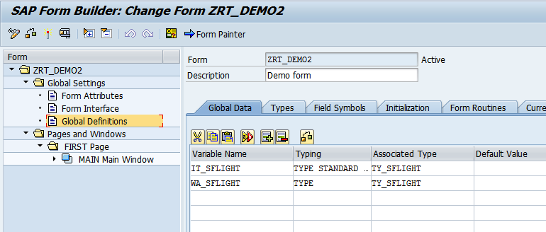

3) In the Types tab , declare the following.

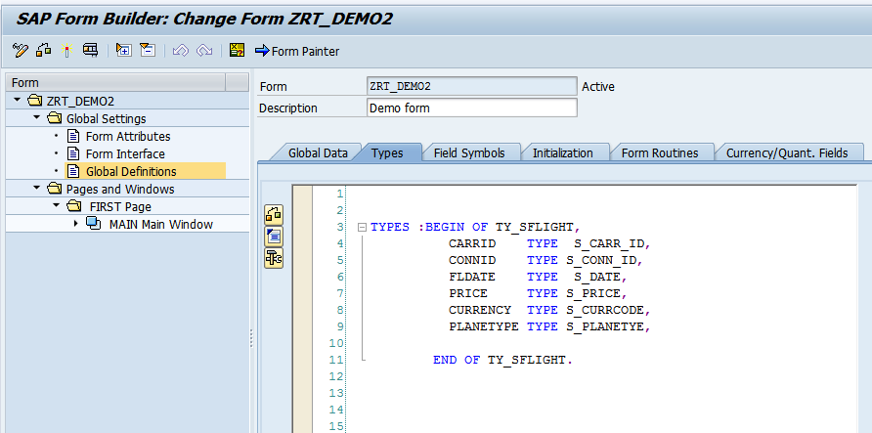

4) Right click on Main window.  
 Create-Flow Logic-Program Lines

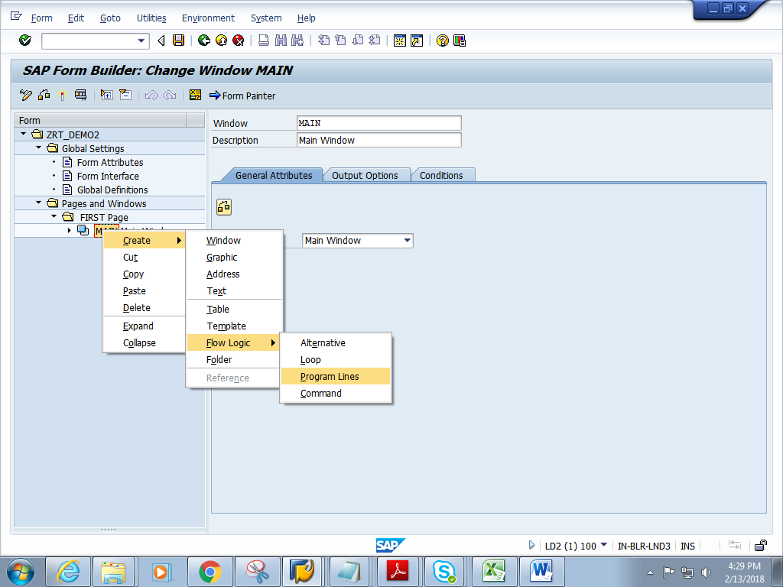

5) Double click on the code1.Give short description.

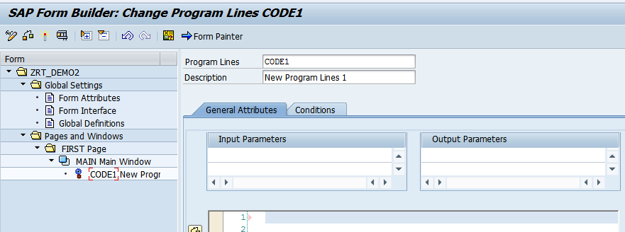

6) Add the below logic. Give the Input and output parameters as shown.

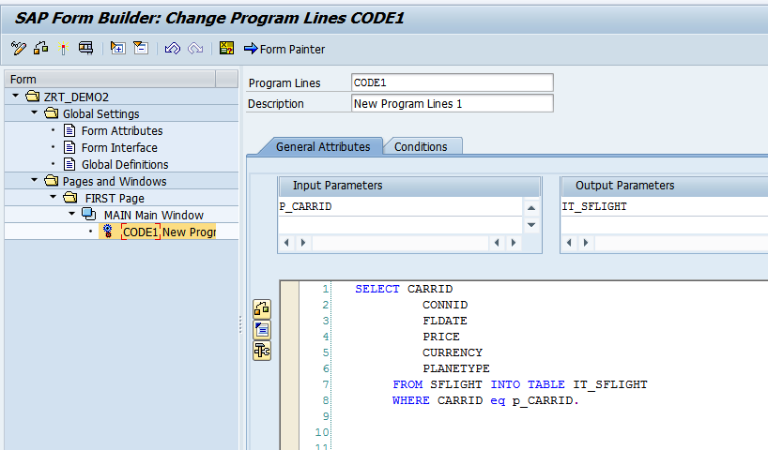

7) Right click on CODE1. Create->Table.

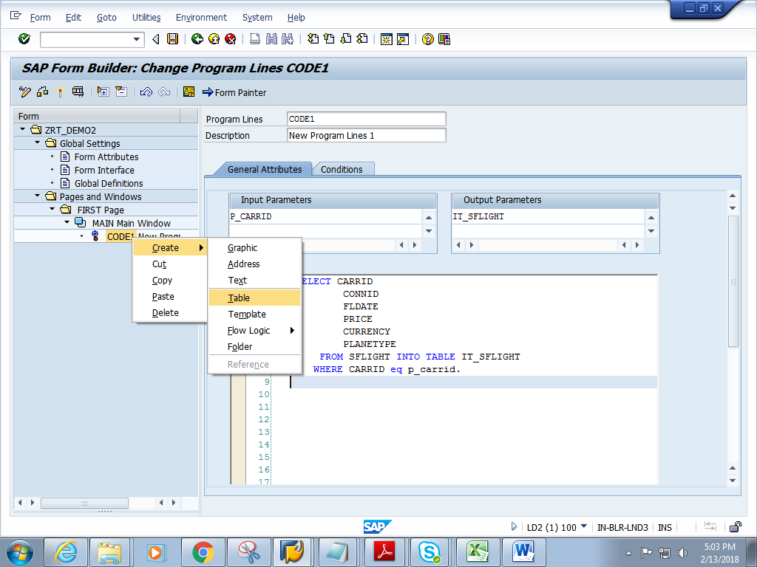

8) Click on the Details button

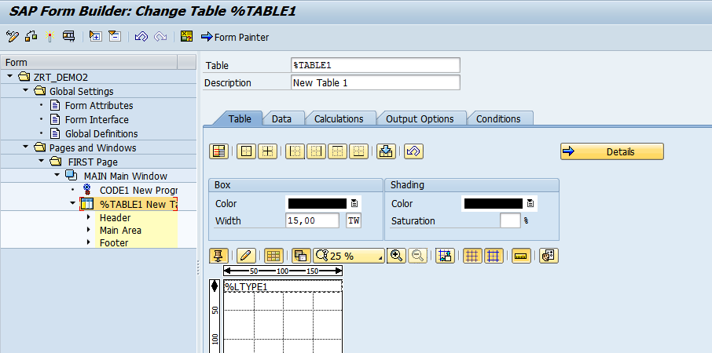

9) Give the name of Line type as L1.Give the width of each column. (Ensure that the sum of column width totals up to the table width of 20CM. Note 'Give the total Table width lesser than 22 CM since A4 paper width is 22CM. )  
Then click on Table Painter

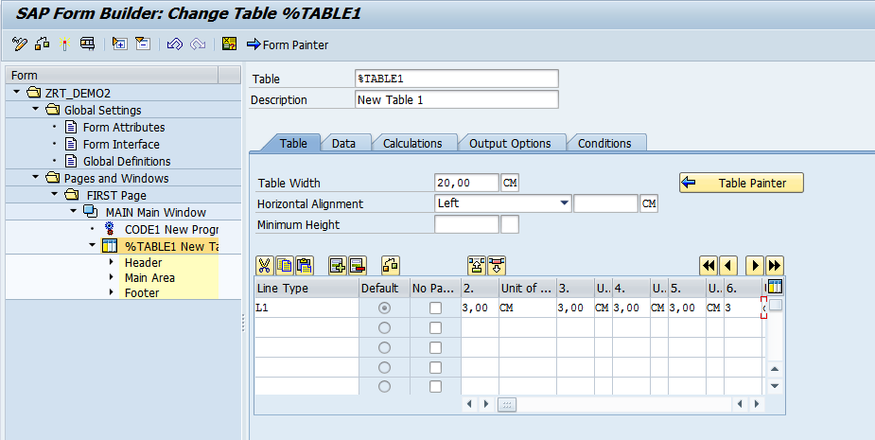

10) Click on select pattern.

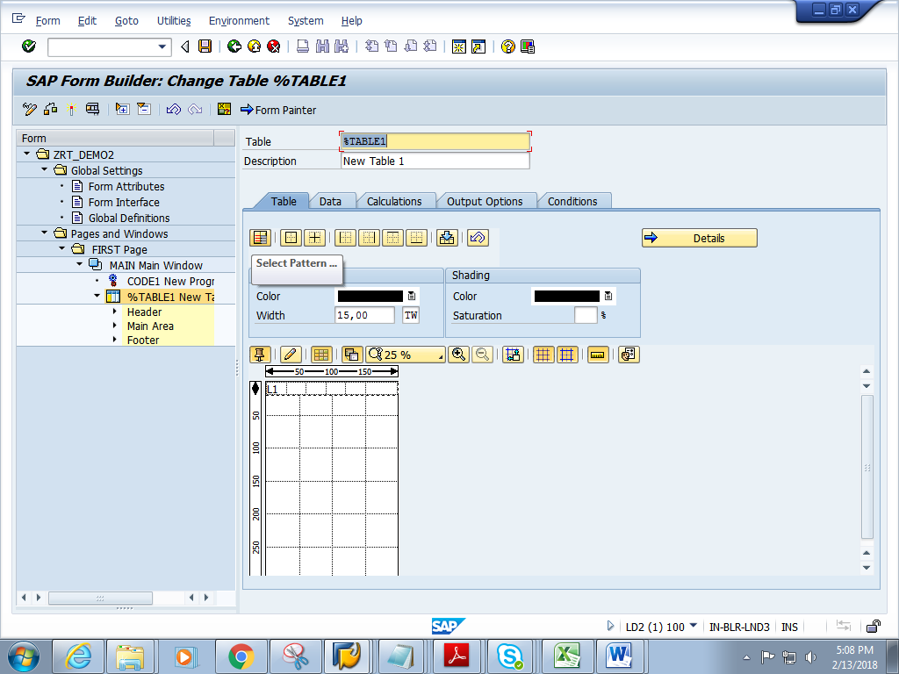

11) Choose the pattern.

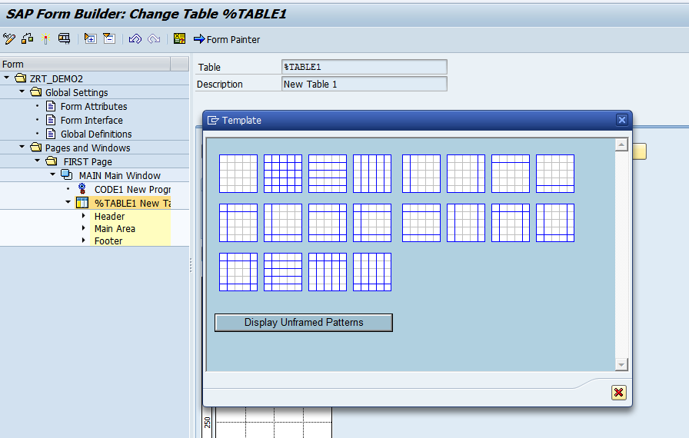

12) Right click on Header. Create ->Table Line

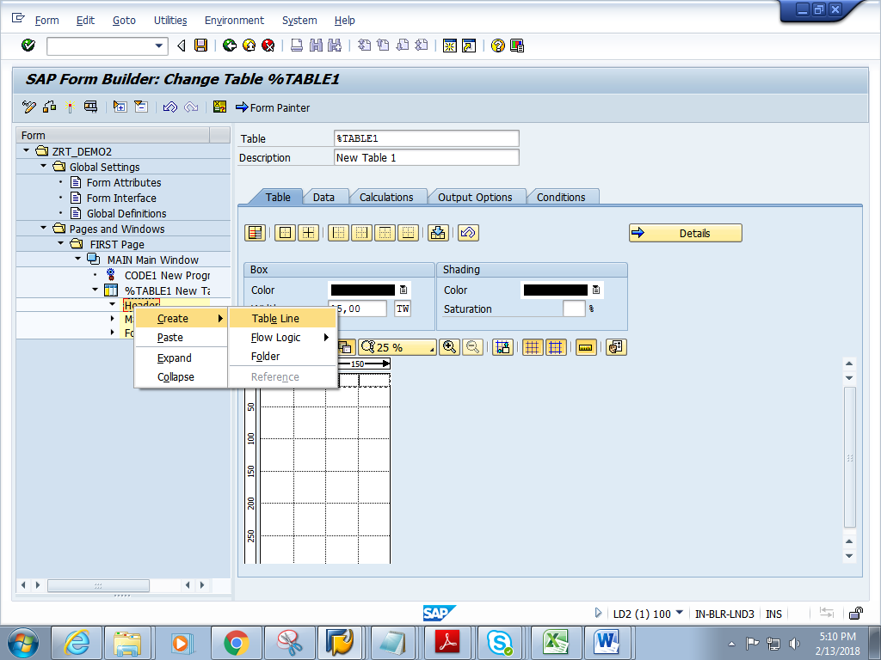

13) In the Data tab, give the internal table and work area name. 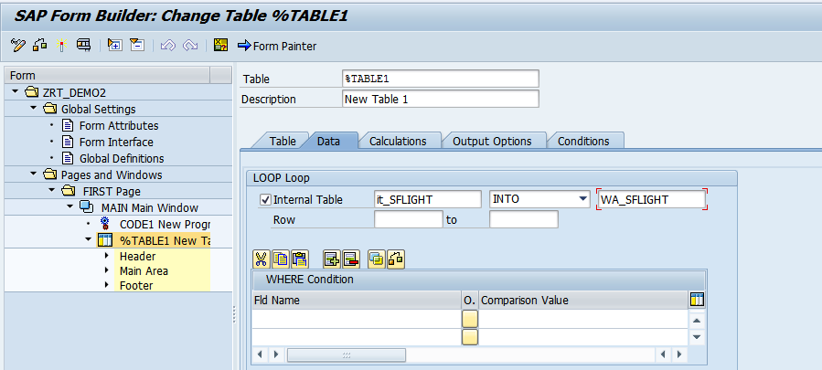

14) Give Line type as L1

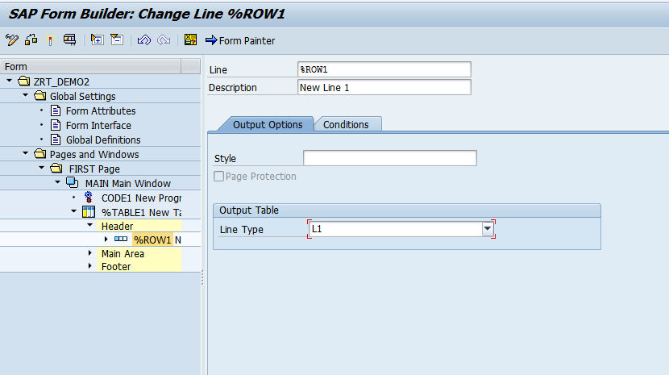

15) Right click on Cell1.Create->Text

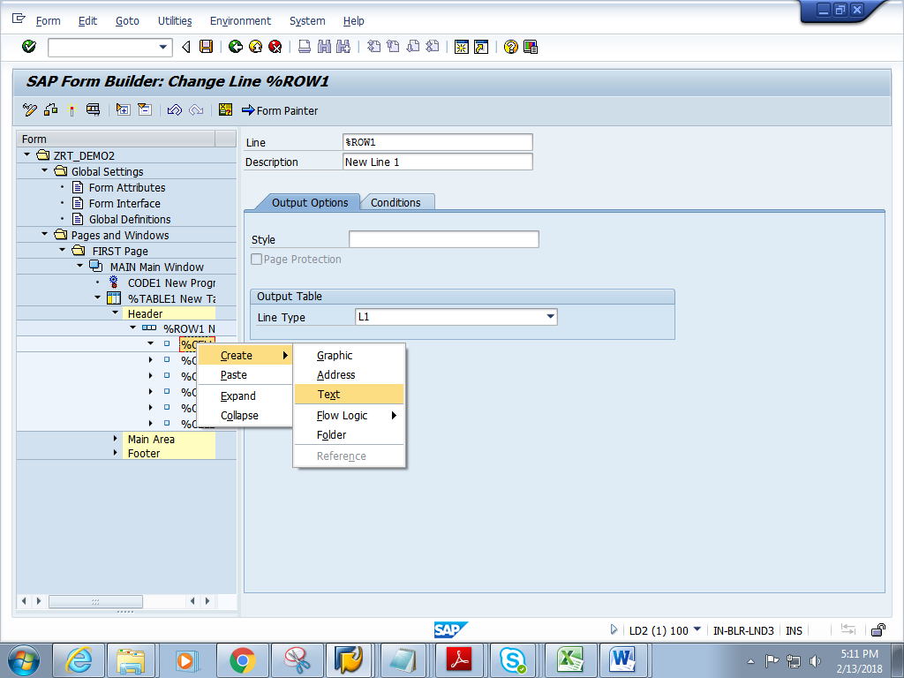

11) Give the header text. And click back.

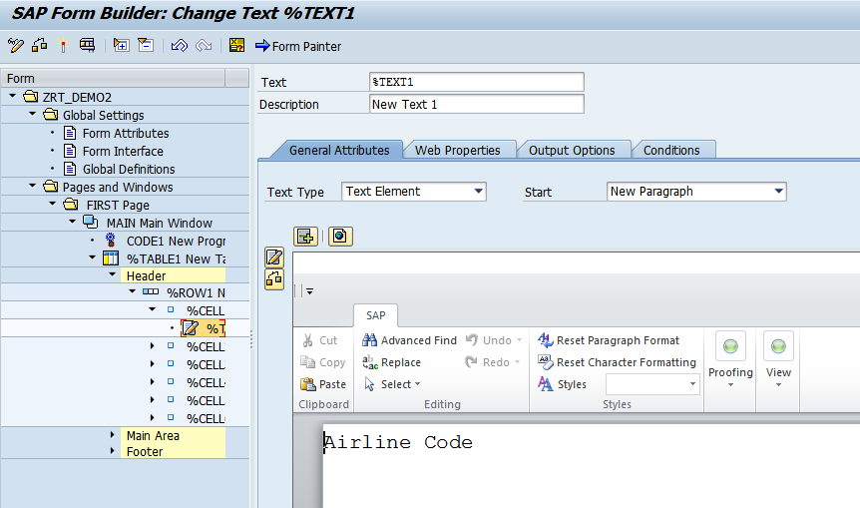

12) Repeat step 10 and step 11 for each cell under the Header .Give suitable Field heading to each field.

13) Right click on Main Area. Create->Table Line

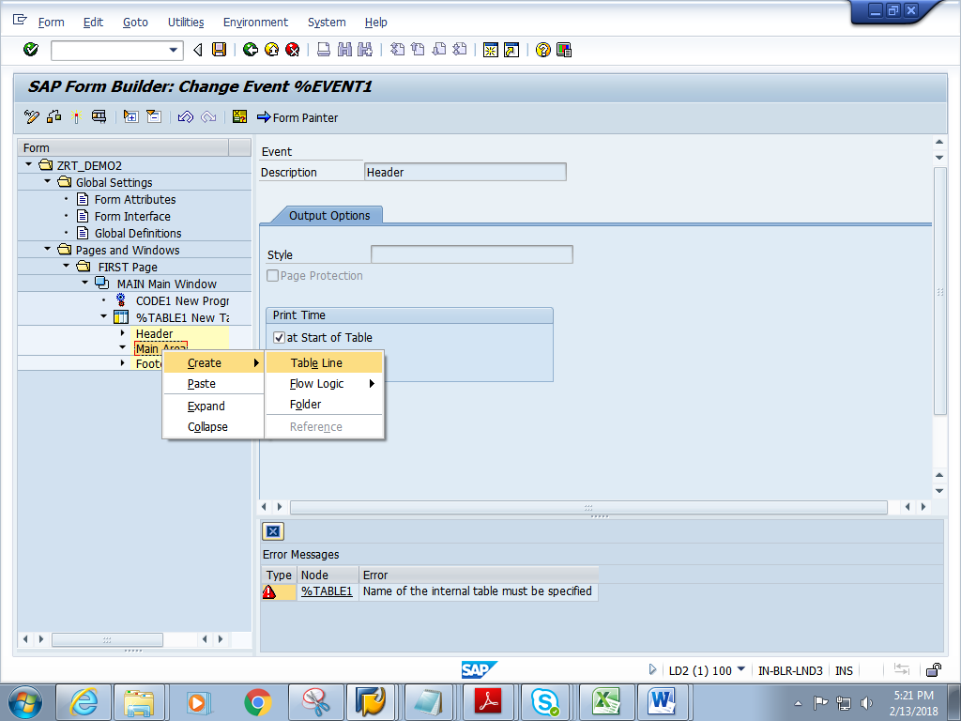

14) Give Line type name as L1.

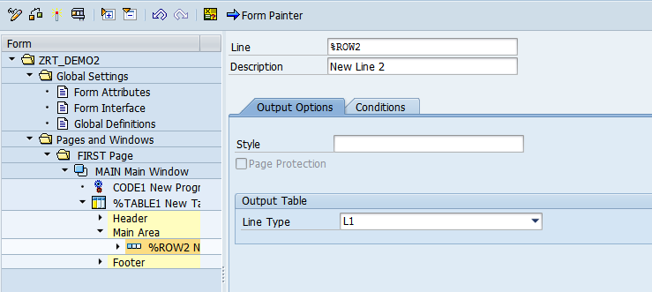

15) Right click on each cell. Create ->Text

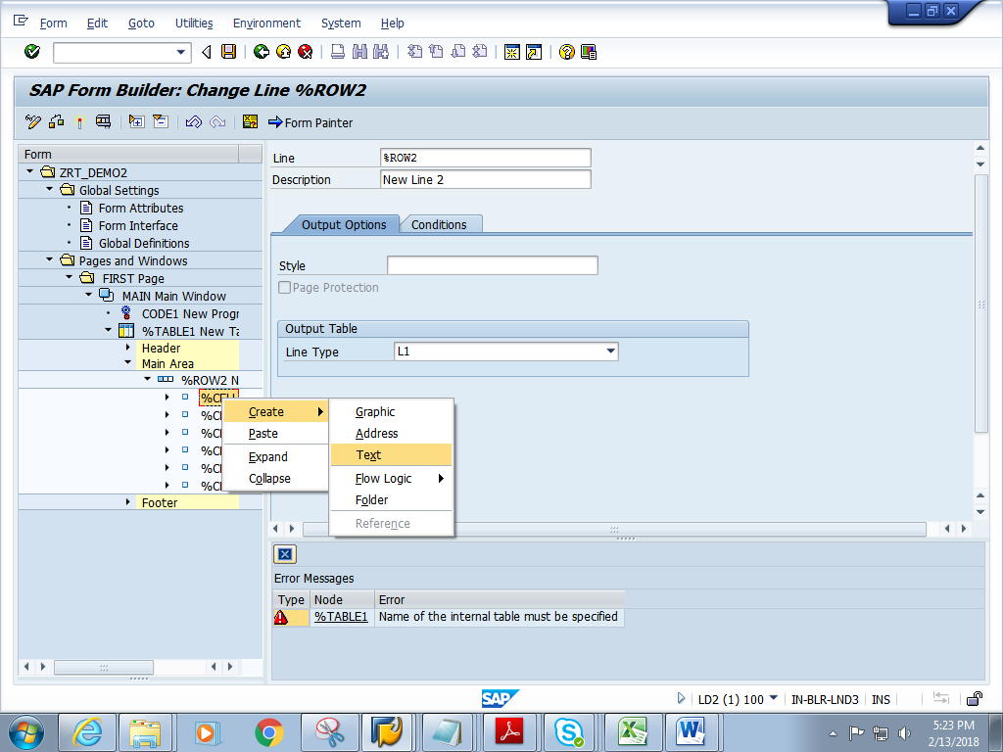

16) Give the work area content of first field

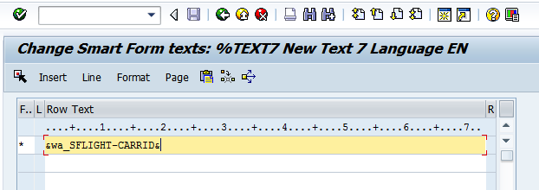

17) Repeat step 15 and step 16 for each cell under the Main Area. Give the work area field names accordingly in each cell.

18) Click on Form Painter. Adjust the Main window by dragging it and place it in suitable position.

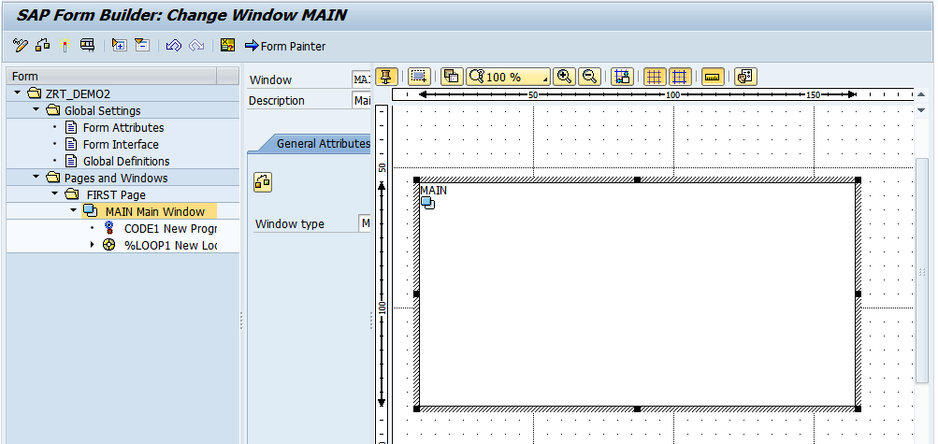

19) Save and activate the form.

20) Execute the form .Execute the function module. **Give the name of the CARRID**.

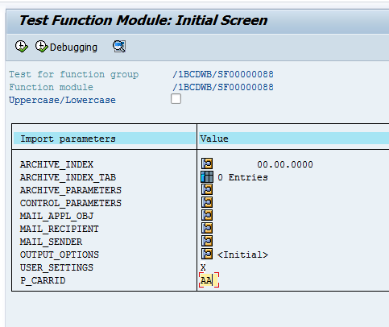

21) Click on Print preview

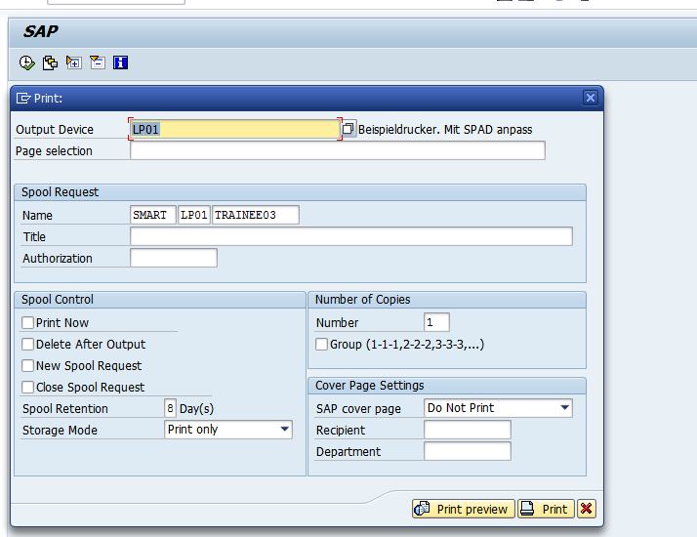

22) Expected output is as follows.

